
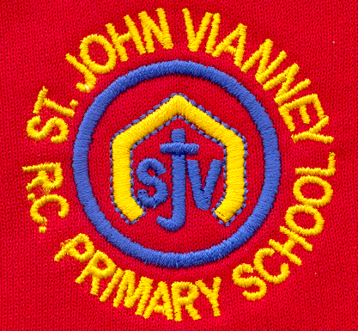

Hillhead Road
West Denton
Newcastle upon Tyne
NE5 1DN
Telephone: 0191 2672233
Fax: 0191 2679538
admin@stjohnvianney.newcastle.sch.uk
www.stjohnvianney.newcastle.sch.uk

Mr A M Duffy
Headteacher
St. John Vianney Catholic Primary School
©

8th November, 2019
Dear Parents and Carers,

Christmas Productions
We have, this week, finalised dates for our Christmas productions. These are as follows:
Rainbow Nursery Nativity: Wednesday 11th December at 10.00am in the Nursery classroom
Sunshine Nursery Nativity: Wednesday 11th December at 2.00pm in the Nursery classroom
Mrs Duffy’s Reception Class Nativity: Tuesday 17th December at 2.15pm in the school hall
Mr Cowen’s Reception Class Nativity: Wednesday 18th December at 2.15pm in the school hall
Year 1 Christmas Performance for both Y1 classes (Mrs McLean and Mrs Langford/Mrs Dunsford’s classes): Monday 9th December at 2.15pm in the school hall
Year 2 Nativity for both Y2 classes (Miss Cherry and Miss Prayle’s classes): Tuesday 10th December at 2.15pm in the school hall
Year 3 Advent Service for both Y3 classes (Mr Galley and Miss Dean’s classes): Thursday 28th November at 2.15pm in the school hall
Year 4 Advent Service for both Y4 classes (Mr Peacock and Mr Bonnar’s classes): Friday 29th November at 2.15pm in the school hall
Year 5 (both classes) and Year 6 Production: Wednesday 11th December at 5.30pm in church.

For performances in school, tickets will be limited to two per family due to limited space in the school hall. It may well be a squash and a squeeze but we are doing our best to ensure that our children are still able to share the most important Christmas message of all with their parents and carers. We look forward to a wonderful month of Nativity productions.
Tickets will be sent home over the course of the next few weeks so please keep a look out for these.

Home-School Reading Books
Great news! Most of our new home-school Reading books have arrived in school and we are in the process of organising and cataloguing the books into our Home-School Reading scheme. We will write to you next week to inform you when we will be in a position to send out our new home-school Reading books.

Year 1 Liturgy
Mrs Langford and Mrs Dunsford’s Year 1 class would like to invite their parents, carers and friends into school on Wednesday morning, 13th November, at 9.15am for their Class Liturgy. The children have been working very hard preparing for this and we look forward to seeing many of you there on Wednesday.

Children In Need – Friday 15th November
Next Friday is Children In Need day. Children are invited to come into school in their own clothes to support this event. Mrs Simonsen will be drawing a Pudsey Bear in chalk on the school yard and children will be invited to bring any loose change to cover Pudsey on the yard. All money raised will be donated to Children In Need. Thank you in advance for your support and generosity.

Year 6 Remembrance Service
Today, our Year 6 children took part in a Remembrance Service with Year 6 children from Knoplaw and Milecastle Primary schools. It really was a moving and touching tribute that commemorated British service members who have died in wars and military conflicts since the onset of World War 1. Our children approached it, as always, with respect and reverence. Thank you to everyone involved in the organisation of this event and to Father Martin, who led the service.
At the going down of the sun and in the morning, We will remember them.

PTFA
Thank you to everyone who bought raffle tickets for our Autumn Raffle – it raised over £550.00. The PTFA Fashion Show also raised over £550.00 so thank you to everyone involved and to all of our parents and carers for their generosity in helping our PTFA to raise funds to benefit the children of our school.

Mini Vinnies Meeting on 11th November
The next Mini Vinnies meeting will take place next Monday, 11th November, from 3.15pm – 4.15pm.
Our Mini Vinnies will be tasked with the job of organising our Travelling Nativity bags, which we will be sending out again this year during Advent. This was very well-received last year and we look forward to our children sharing the real message of Christmas at home again with their families this year.

Thank you for your continued support of our school.

Yours sincerely,
Mr A M Duffy
Headteacher










