


Hillhead Road
West Denton
Newcastle upon Tyne
NE5 1DN
Telephone: 0191 2672233
Fax: 0191 2679538
admin@stjohnvianney.newcastle.sch.uk
www.stjohnvianney.newcastle.sch.uk

Mr A M Duffy
Headteacher
St. John Vianney Catholic Primary School

11th October, 2019
©
Dear Parents and Carers,
Harvest Mass
We will be collecting contributions of tins and packets of food for our Harvest Mass, which will take place next Friday in church. Unfortunately, due to number restrictions in church, we are unable to extend the invite to parents and carers since the church can accommodate 250 pupils and our school population is over 400 pupils. All donations should be brought into school next week and these will be blessed by Father Martin at Mass on Friday. Thank you in advance for your generosity.

Congratulations Mrs Watanabe!
I’m sure you will join me in congratulating Mrs Watanabe on the birth of her beautiful baby son, Akira. Both Mrs Watanabe and Akira are doing well and we wish Mr and Mrs Watanabe every happiness with their new arrival.

PTFA Fashion Show
This is just a reminder that our PTFA are hosting a Fashion Show on Saturday 2nd November at West Denton Community Centre, Hillhead Road. This is a chance for you to shop your favourite high street brands at 50% off or more! Tickets cost £6.00 each and they are available from Mrs Marsh. Please see the poster at the entrance to school for more information.

Parents Evening
By now, you will have received a letter about Parents Evening on Monday 21st, Tuesday 22nd and Wednesday 23rd October. Please return your reply slip to school by MONDAY so that class teachers can allocate times for meetings. Many thanks.

Earrings in school
Can I please remind you once again that earrings are not allowed in school for health and safety reasons. This includes the transparent retainer earrings that a number of children are wearing in school. The retainer earrings can also cause injury, which is why we ask you to support us in our school uniform policy. Can I thank the vast majority of parents and carers who do support us when politely requested to do so.

Yours sincerely,

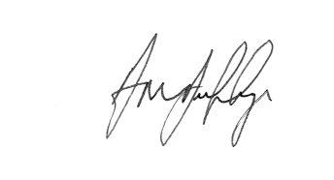
Mr A M Duffy
Headteacher










