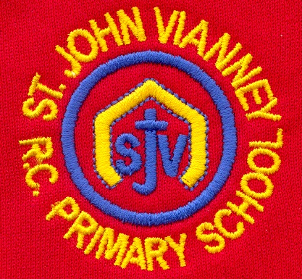

**French**

Children will learn how to ask for food and drink in French and participate in a Café scenario ordering food and taking orders. They will reinforce their number knowledge to 100 and learn to give their opinions on food.

**PE**

Dance; Outdoor and Adventurous; Counter balance; floor balance

**Year Five – Spring Term**

**Science**

***Earth and Space***

Describe the movement of the Earth, and other planets, relative to the Sun in the solar system

Describe the movement of the Moon relative to the Earth

Describe the Sun, Earth and Moon as approximately spherical bodies

Use the idea of the Earth’s rotation to explain day and night and the apparent movement of the sun across the sky.

*Working scientifically:*

Identifying scientific evidence that has been used to support or refute ideas or arguments.

Taking measurements, using a range of scientific equipment, with increasing accuracy and precision, taking repeat readings.

**English**

***‘Malamander’ by Thomas Taylor*** Narrative; setting description; letters; instructions; dialogue; newspaper report

***‘The Matchbox Diary’ by Paul Fleischman***

Diary entry; letters; explanation text

***Poetry:* Poems with figurative language**

Poems by Joseph Coelho

***Grammar:*** Relative clauses beginning with who, which, where, when, whose,

Modal verbs – might, should, will, must

Linking across paragraphs using adverbials of time e.g. Later/time, nearby/place, secondly/number or tense choice

Brackets, dashes, commas to indicate parenthesis

**PSHE**

***Health and Wellbeing***

***Living in the Wider World***

***Relationships***

**Music**

Children will begin to learn to play the guitar and keyboard and they will work as part of an ensemble to perform musical pieces.

**Computing**

Programming; Connecting Crumbles; Combing output components, Controlling with conditions, Starting with selection, drawing designs; Writing and testing algorithms

**Design Technology**

**Electrical Systems:** Monitoring and control; Crumble

**Mathematics**

***Place Value:***  numbers up to 1,000,000; negative numbers

***Calculation:*** formal written methods of addition, subtraction, multiplication and short division; factors and multiples

***Fractions, Decimals and Percentages:***

equivalent fractions; mixed numbers; improper fractions; order and compare decimals

***Measurement:*** perimeter; area

***Geometry:*** 3D shapes; 2D shapes; angles

***Problem solving***

**History *Egyptians***

Understand how the Egyptians communicated ideas.

Use first and secondhand sources to make observations about daily life for the Ancient Egyptians.

To understand who the Egyptians worshipped.

**Art**

***Formal elements: Architecture***

Observational drawing; Monoprinting; Hundertwasser House; Be an architect; Monument.

**Geography**

***Food:*** Children will learn about seasonal foods; Explore where food comes from; How it is distributed; Food miles and sustainable food.

**Religious Education**

**Local Church - Community*: Mission***

Continuing Jesus’ mission in diocese (ecumenism)

**Eucharist - Relating: *Memorial Sacrifice***

Eucharist as the living memorial of Christ’s sacrifice

**Lent/Easter – GIVING: *Sacrifice***

Lent: a time of aligning with the sacrifice

***Other Faiths:*** **Islam**

Beliefs and festivals – Ramadan and Pilgrimage