
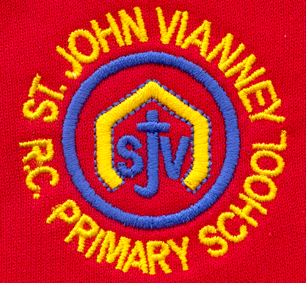

Hillhead Road
West Denton
Newcastle upon Tyne
NE5 1DN
Telephone: 0191 2672233
Fax: 0191 2679538
admin@stjohnvianney.newcastle.sch.uk
www.stjohnvianney.newcastle.sch.uk

Mr A M Duffy
Headteacher
St. John Vianney Catholic Primary School
©

11th February, 2019
Dear Parents and Carers,

St. John Vianney are in the top 3% of schools in England!
On Monday, I received a letter from the Rt Hon Damian Hinds MP (Secretary of State for Education) and the Rt Hon Nick Gibb MP (Minister of State for School Standards) congratulating us on the very high level of progress that pupils in our school made in the end of Key Stage 2 assessments last year.
The progress that our children made between Key Stage 1 and the end of Key Stage 2 put St. John Vianney in the top 3% of schools in England. He wrote,
“We would like to congratulate you, your staff and your pupils on the very high level of progress that pupils in your school demonstrated in the reading, writing and mathematics Key Stage 2 assessments last year.

We want to equip every child with the fluency in reading, writing and mathematics necessary to prepare them for a successful secondary education and beyond, and your school has provided this.

Thank you for producing such high standards through your hard work and professionalism, and congratulations again to you and your staff for all you have achieved.”

It is always very special when our hard work is acknowledged externally so well done to everyone in the community of St. John Vianney school.

Good luck Mrs O’Neill!
After the half-term holidays, Mrs O’Neill will be leaving St. John Vianney school as she begins her Maternity Leave and awaits the arrival of her new baby. I’m sure you will join me in wishing Mrs O’Neill all the very best of luck.
Mrs Langford, who has been working in Year 1 since January, will take over from Mrs O’Neill and she will be teaching the children alongside Mrs Dunsford, who has been a valued teacher here at St. John Vianney school for many years. Mrs McLean will continue to teach her Year 1 class on a full-time basis for the rest of this academic year.

Durham Vocal Festival
I was immensely proud of our School Choir, who represented the school in such a wonderful way at the Durham Vocal Festival Choir competition. Every single member sang their hearts out! I must say a big thank you to Miss West and to all of our children whose behaviour and conduct was impeccable. They were, as always, an absolute credit to our school.

Year 3 Liturgy
Miss McMaster’s Year 3 class would like to invite their parents, carers and friends to their Class Liturgy on Wednesday morning at 9.15am in the school hall. We look forward to seeing many of you there.

Well done to our Football Team!
Well done to our Football Team, who beat St. Bede’s school 8-0 in the Catholic Schools Knockout Cup on Friday evening. We now have a quarter final and a semi-final to look forward to next term!

School Questionnaire
The online questionnaire will remain open until Monday 25th February.

Thank you for your continued support of our school.

Yours sincerely,
Mr A M Duffy
Headteacher











