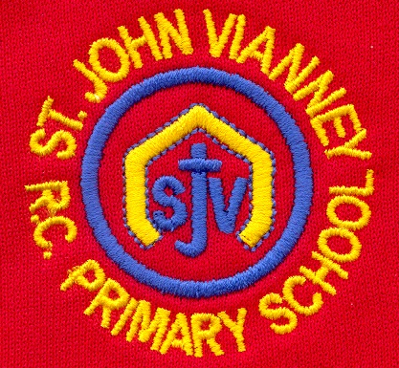

**P.E.**

**Dance:** Create a simple dance in pairs.

**Games:** Focus on: speed, agility, quickness.

**Science**

***Rocks:*** The children will learn to identify, examine and understand how different types of rocks are formed.

***Animals, including humans:*** Children will learn about the human body and the diet and habitat of animals.

**Year Three – Autumn Term**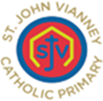

**Music**

***Singing:*** Posture, Pitch, Dynamics, Tempo, Call and response, Harmonies, Reading Rhythms and Composition.

**PSHE**

Health and Wellbeing; Relationships; Living in the Wider World.

**French**

The children will learn to use greetings, nouns and proper nouns, classroom instructions and numbers, and they will study Paris, countries of the UK and capital cities of the UK.

**Mathematics**

***Number and Place value:*** Children will work with numbers up to 1000. They will compare and order numbers and explore number patterns and place value.

***Addition and Subtraction:*** Children will add and subtract numbers using the column method of Addition and Subtraction. This includes changing the tens and ones.

***Multiplication and Division:*** Children will multiply and divide by 3, 4 and 8 and they will solve word problems. Children will multiply and divide two-digit numbers and solve reasoning challenges using the strategies developed.

In Year 3, children will practise times tables daily.

**Religious Education**

***Domestic Church - Family***

God is present in every home.

***Baptism/Confirmation – Belonging***

The Promises made at Baptism and Confirmation are the call to a new way of life.

***Advent/Christmas – Loving***

The coming of God, in the person of Jesus, 2000 years ago at Bethlehem.

***Other Faiths - Judaism***

The synagogue and symbols in Judaism.

**English**

***Fairy Tales*** – Reading a wide range of Fairy Tales. Children will write a character description, persuasive advert, informal letter and dialogue between key characters in Fairy Tales.

***Poetry: Poems on a Theme – ‘In Flanders Fields’ by John McCrae***

Children will read, recite and write poems, including Acrostic and Blackout poems.

***Biography Writing - Little People: Big Dreams: David Attenborough***

Children will write a Factfile and Biography about Sir David Attenborough.

***Grammar:*** Ensure that the children use and understand the correct terminology, e.g. parts of speech, sentence construction and punctuation.

***Handwriting:*** Continue to use the diagonal and horizontal strokes that are needed to join letters.

**Computing**

***E-safety:*** The children will learn about password safety and security of devices used. They develop their awareness of appropriate behaviour online.

**History**

***Stone Age:*** Children will use a variety of artefacts and sources to learn about this period of History.

**Design Technology**

***Levers and Linkages:*** Children will explore various levers and linkages and design their own moving Christmas card.

**Art**

***Botanical Drawing:*** Children will develop shading and drawing techniques to create botanical inspired drawings.

**Geography**

***Where I Live:*** Children will learn about their local settlement, different types of settlements and problems in towns/cities/rural areas.