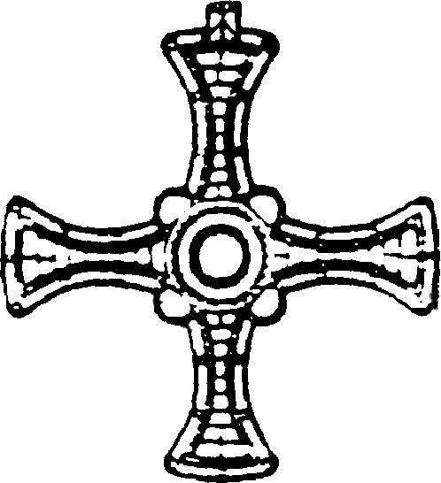
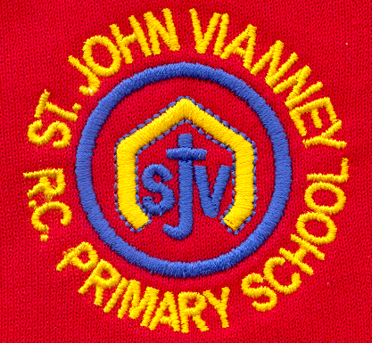

Hillhead Road
West Denton
Newcastle upon Tyne
NE5 1DN
Telephone: 0191 2672233
Fax: 0191 2679538
admin@stjohnvianney.newcastle.sch.uk
www.stjohnvianney.newcastle.sch.uk

Mr A M Duffy
Headteacher
St. John Vianney Catholic Primary School
©

Dear Parents/Carers of Year 4 Children – September 2019

First Holy Communion Programme 2019/2020
In the coming academic year, the children in Year 4 who have been baptised in the Roman Catholic Church will prepare to receive the Sacraments of Reconciliation and Holy Communion for the first time.

The dates for the course, any masses the children have to attend and the celebrations are outlined below. Please enter these dates into your diaries. Father Martin Morris, Parish Priest, looks forward to meeting with all parents and carers of our Holy Communion children on Thursday 3rd October at 6.00pm in the church hall.

Thursday 3rd October 2019
Parents and carers meeting in St John Vianney church hall with Father Martin
6.00pm – 6.45pm

Thursday 10th October 2019
Session 1 in school
3.30 pm – 4.45 pm

Sunday 13th October 2019
Holy Mass in St Cuthbert’s church on Saturday 12th October at 5.30pm
Or
St John Vianney church at 11.00 am on Sunday 13th October

Thursday 7th November 2019
Session 2 in school
3.30 pm – 4.45 pm

Sunday 10th November 2019
Holy Mass in St Cuthbert’s church on Saturday 9th November at 5.30pm
Or
St John Vianney church at 11.00 am on Sunday 10th November

Thursday 5th December 2019
Session 3 in school
3.30 pm – 4.45 pm

Sunday 8th December 2019
Holy Mass in St Cuthbert’s church on Saturday 7th December at 5.30pm
Or
St John Vianney church at 11.00 am on Sunday 8th December

Thursday 9th January 2020
Session 4 in school
3.30 pm – 4.45 pm

Sunday 12th January 2020
Holy Mass in St Cuthbert’s church on Saturday 11th January at 5.30pm
Or
St John Vianney church at 11.00 am on Sunday 12th January

First Reconciliation Service in St John Vianney church
Thursday 16th January 2020 at 5.00pm in St. John Vianney church

Thursday 6th February 2020
Session 5 in school
3.30 pm – 4.45 pm

Sunday 9th February 2020
Holy Mass in St Cuthbert’s church on Saturday 8th February at 5.30pm
Or
St John Vianney church at 11.00 am on Sunday 9th February

Thursday 12th March 2020
Session 6 in school
3.30 pm – 4.45 pm

Sunday 15th March 2020
Holy Mass in St Cuthbert’s church on Saturday 14th March at 5.30pm
Or
St John Vianney church at 11.00 am on Sunday 15th March

Thursday 23rd April 2020
Session 7 in school for MR BONNAR’S CLASS ONLY
3.30 pm – 4.45 pm

Saturday 25th April 2020
First Holy Communion Celebration in St John Vianney church for the children in MR BONNAR’S CLASS ONLY
10.00 am

Sunday 26th April 2020
Holy Mass in St Cuthbert’s church on Saturday 25th April at 5.30pm
Or
St John Vianney church at 11.00am on Sunday 26th April for MR BONNAR’S CLASS ONLY

Thursday 30th April 2020
Session 7 in school for MR PEACOCK’S CLASS ONLY
3.30pm – 4.45 pm

Saturday 2nd May, 2020
First Holy Communion Celebration in St John Vianney church for the children in MR PEACOCK’S CLASS ONLY
10.00 am

Sunday 3rd May, 2020
Holy Mass in St Cuthbert’s church on Saturday 2nd May at 5.30pm
Or
St John Vianney church at 11.00am on Sunday 3rd May for MR PEACOCK’S CLASS ONLY

Some important information
It is assumed that every child who is a baptised Catholic in St. John Vianney school will make their First Holy Communion. If there is a reason why your child, who is a baptised Catholic, will not be making their First Holy Communion, then you must make an appointment to come and see me to discuss this matter further.

The First Holy Communion sessions will be carried out in school by Miss Elliott, Mr Bonnar, Mr Peacock and the catechists from our parish, who will be helping our children in their preparation. Children should be collected at 4.45pm from the main entrance to school after each First Holy Communion session.

On the day of the children’s First Holy Communion, Mass will last approximately 90 minutes and photographs will then be taken by a professional photographer. This can take up to 60 minutes, after which the children will share a breakfast with all of the children who have made their First Holy Communion that day. Can I therefore recommend that any celebrations that you take part in afterwards with your family are not organised before 1.00pm since the children usually leave the Hall around that time.

I look forward to another wonderful year of preparation and First Holy Communion celebrations this year.

Thank you for your continued support.

Yours sincerely,
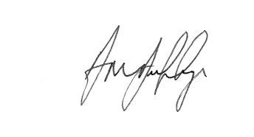
Mr A M Duffy
Headteacher






