
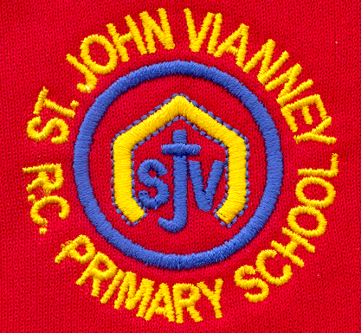

Hillhead Road
West Denton
Newcastle upon Tyne
NE5 1DN
Telephone: 0191 2672233
Fax: 0191 2679538
admin@stjohnvianney.newcastle.sch.uk
www.stjohnvianney.newcastle.sch.uk

Mr A M Duffy
Headteacher
St. John Vianney Catholic Primary School
©

22nd September, 2020

To the Families of children in Year 4,

As you will be aware, we have worked very hard in order to ensure that our school is a Covid-secure and safe place for our pupils and our staff.

We have carefully followed all of the public health advice and guidance, and have carried out an in-depth risk assessment in order to put in place measures to minimise the risk of the virus spreading. This risk assessment is regularly reviewed as guidance is updated.

However, while the virus remains with wider society – and with cases in our area now rising – it is perhaps to be expected that we will experience some cases within our school community.

Unfortunately, we have had a pupil in Miss Prayle’s class test positive and, due to them being required to self-isolate at home, we have followed guidance from Public Health England and made the decision to close Miss Prayle’s Year 4 class bubble.

We are sorry that we have to take this step and we understand that this will cause inconvenience for many of you.

However, at this time, we have no choice but to take this action to ensure the safety of staff and pupils while they are in school in line with Public Health England guidance.

This is a temporary arrangement. We hope to reopen to Miss Prayle’s class bubble on Tuesday 6th October but we will let you know when this is confirmed.

Please also know that we are following all of the public health guidance and, if your child is identified as being a confirmed close contact with a person who has tested positive, you will be notified and advised of the correct procedure to follow at home.

As a precaution, we have taken steps to collapse Mr Peacock’s class bubble in the interim. We are still awaiting confirmation of this from Public Health England and, should the guidance from Public Health England change, we will contact you immediately.

Your child’s teacher will be in touch regarding work your child will be set in order to continue their studies at home.

We thank you for your ongoing support and will continue to keep you informed and up-to-date.
With my very best wishes,
Mrs Meldrum
Acting Headteacher

