
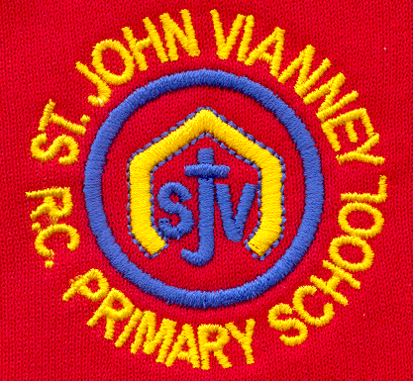

Hillhead Road
West Denton
Newcastle upon Tyne
NE5 1DN
Telephone: 0191 2672233
Fax: 0191 2679538
admin@stjohnvianney.newcastle.sch.uk
www.stjohnvianney.newcastle.sch.uk

Mr A M Duffy
Headteacher
St. John Vianney Catholic Primary School

3rd June, 2020

Dear Parents and Carers,

I hope that you are all well.

Just over a week ago, I wrote to you explaining that due to the significant increase in the number of key worker children requiring a place in school, we were unable to open up further on the 1st of June to accommodate this additional demand.

In order to be able to safely absorb the amount of children needing places back into school, thorough and robust risk assessments needed to be completed and consulted on; we have been working alongside Newcastle Local Authority and the Governing Body to achieve this.

We have used Government and Local Authority guidance to support us in our planning and decision-making, enabling us to now be in a position where we feel we are capable of expanding our current provision as safely as we possibly can.

I am writing to you today to share our initial plans for the phased, partial re-opening of St John Vianney Primary School. Following the development of an extensive risk assessment, Governors have decided to open school on the 8th of June to our expanded priority group of key workers and vulnerable children only. As I mentioned in previous correspondence, the number of these families has increased significantly, meaning that we will be welcoming back 70 children over the course of next week. We will be contacting the key worker families to confirm the days that they have been allocated.

While the Government are suggesting pupils in Nursery, Reception, Year 1 and Year 6 could potentially return to school, the Governing Body have decided that the decision to focus on Key Workers first is the safest option. I will keep you updated in due course.

I would like to reiterate at this point, that choosing to send your child back to school during these challenging times is entirely your decision. The reality is that, despite our best efforts to put into place the most stringent rules and procedures, the possibility of the virus spreading in school cannot be completely eradicated. It is perfectly understandable that some of you are anxious and apprehensive about your child returning to the classroom. You must decide what is best for your child and your family and we will support and respect whatever decision you make.

If our systems and routines prove over the next couple of weeks to be safe and robust, we may be in a position to welcome back more children from Year 6 whose parents wish to send them back to school.

Regrettably, for the vast majority of our children, school will continue to be closed. We would love nothing more than to be able to see everyone back where they belong but, as I am sure you will understand, we must take small steps carefully and cautiously with the welfare of children and staff and the families of children and staff always at the centre of our plans.

I appreciate that many children and families will be extremely disappointed that they cannot return to school yet or as soon as they had hoped. I am also very aware that not being able to send your child back to school may present challenges for families. However, I hope you will understand the great responsibility that I, and the Governors, have to make sure that our actions now will result in the best interests of our families and our school community in the future.

I very much look forward to when we can all be back together. Until that time, thank you for your understanding, patience, trust and support.

Yours sincerely,

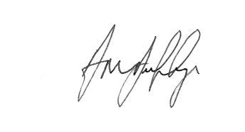
Mr A M Duffy
Headteacher











