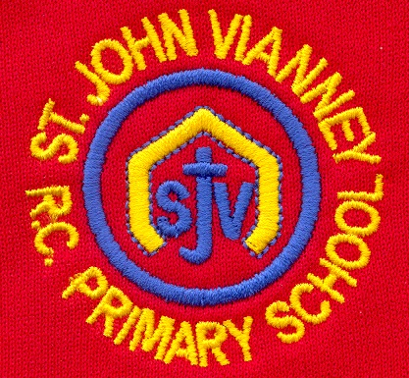

**PSHE**

*Health and Wellbeing*

*Living in the Wider World*

*Relationships*

**Science**

**Forces**

* Explain that unsupported objects fall towards earth because of the force of gravity acting between the Earth and the falling object.
* Identify the effects of air resistance, water resitance and friction, that act between moving surfaces.
* Recognise that some mechanisms including levers, pulleys and gears allow a smaller force to have a greater effect.

**Animals (including humans)**

* describe the changes as humans develop to old age.

**Music**

The children will write music using crotchets, quavers, minims, semi-quavers and more complex time signatures to make their own compositions. They will then perform this as part of an ensemble.

**History: Early Islamic Civilisation**

Children will learn why the Early Islamic Civilisation was a significant turning point in History. They will understand who Muhammad was and why he was so significant.

**Religious Education**

**Pentecost - Serving: Transformation**

Celebration of the Spirit’s transforming power.

**Reconciliation - Relating: Building Bridges**

Admitting wrong, being reconciled with God and

each other.

**Universal Church – World: Stewardship**

The church is called to the stewardship of Creation

***Other Faiths:*** **Islam**

Beliefs and festivals – Ramadan and Pilgrimage

**Computing**

Programming; Connecting Crumbles; Combing output components, Controlling with conditions, Starting with selection, drawing designs; Writing and testing algorithms

**French**

Learning about saying which sports we play and hobbies we have. Introducing verbs *jouer* and *faire.*

**Mathematics**

**Fractions:** Adding fractions; subtracting fractions; multiplying whole numbers by proper fractions; multiplying mixed numbers and whole numbers.

**Decimals:** read and write decimals; order and compare; add and subtract decimals; to find number pairs that add up to 1.

**Measurement:** Converting units of length; mass and time; telling the temperature.

**Area and Perimeter:**  Find the perimeter of shapes; find perimeter of different shapes; to measure the area by counting squares; measure area of squares and other shapes; to measure in square metres.

**Volume:**  Understand and find the volume of solids and 3D shapes; capacity of cuboids.

**Year Five – Summer Term**

**English**

***‘The Matchbox Diary’ by Paul Fleischman***

Diary entry; letters; explanation text

***Poetry:* Poems with figurative language**

Poems by Joseph Coelho

**Homework** debate; discussion text

**Grammar:** Pronouns and possessive pronouns; Subordinate clauses; Homophones; Writing cohesive paragraphs; Parenthesis – brackets, dashes and commas; Adverbials and fronted adverbials; Dictionary work; Relative clauses; Direct and indirect speech

**Reading Vipers:** Explain the meaning of words in context; Make inferences; Predict what might happen in the text; Explain meaning; Retrieve information; Summarise events.

**PE**

Swimming, Dance, Athletics, Tennis and Rounders

**Design Technology**

**Electrical Systems:** Monitoring and control; Crumble

**Art**

***Craft and design: Architecture***

Observational drawing – houses; Be an architect; Friedensreich Hundertwasser; Monument

**Geography**

***Food:*** Children will learn about seasonal foods; Explore where food comes from; How it is distributed; Food miles and sustainable food.