
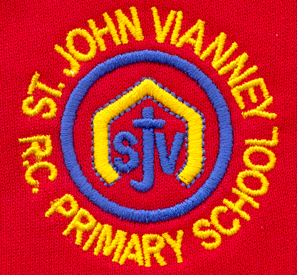

Hillhead Road
West Denton
Newcastle upon Tyne
NE5 1DN
Telephone: 0191 2672233
Fax: 0191 2679538
admin@stjohnvianney.newcastle.sch.uk
www.stjohnvianney.newcastle.sch.uk

Mr A M Duffy
Headteacher
St. John Vianney Catholic Primary School
©

25th October, 2019
Dear Parents and Carers,
Parents Consultation Evening
We had an overwhelming turnout for our Parents Consultation Evenings this week. I must say a very big thank you to you all for your continued support of our school and to my dedicated staff, who have stayed behind for three very late nights to accommodate all of their parents and carers.

Cauliflower Cards
All Cauliflower Cards forms must be returned to school by Monday 4th November if you have completed an online order. We have been assured that all printed cards will be sent to school by the end of November at the very latest. We receive a monetary donation for every pack of cards purchased so this is also an excellent form of fundraising for our school.

Year 6 Liturgy
Thank you to all the parents, carers and friends of Year 6 who came along to their Class Liturgy in school last Wednesday morning. The children led us all in a wonderful Liturgy and it really was an excellent example of our home-school-parish links. Thank you to Year 6 and to everyone involved.

Early Years Request
The Early Years team are looking for someone who could help us with some joinery. We need some shelves put up in our small sheds, benches made with decking boards and small pallets, which we will supply, and a new mud kitchen. If anyone could help, we would be very grateful indeed! If you have some joinery skills and the time to help, please speak to a member of our Early Years team. Many thanks.

Christmas Productions
We are still in the process of finalising the organisation of Christmas events due to the fact that one of our halls is now the Year 5 classroom. We are working very hard to facilitate Christmas productions in a confined space and we will write to you as soon as I have organised the logistics of Christmas. Thank you in advance for your patience in working with us during this time of building work. We are on the last phase now!

ALDI Vouchers
Thank you to everyone who sent ALDI vouchers into school. We have now received the 300 tokens required so we are now in the draw to win £20,000. Keep your fingers crossed!
I hope you all have a lovely half term holiday and I look forward to seeing you back at school on Monday 4th November.

Yours sincerely,
Mr A M Duffy




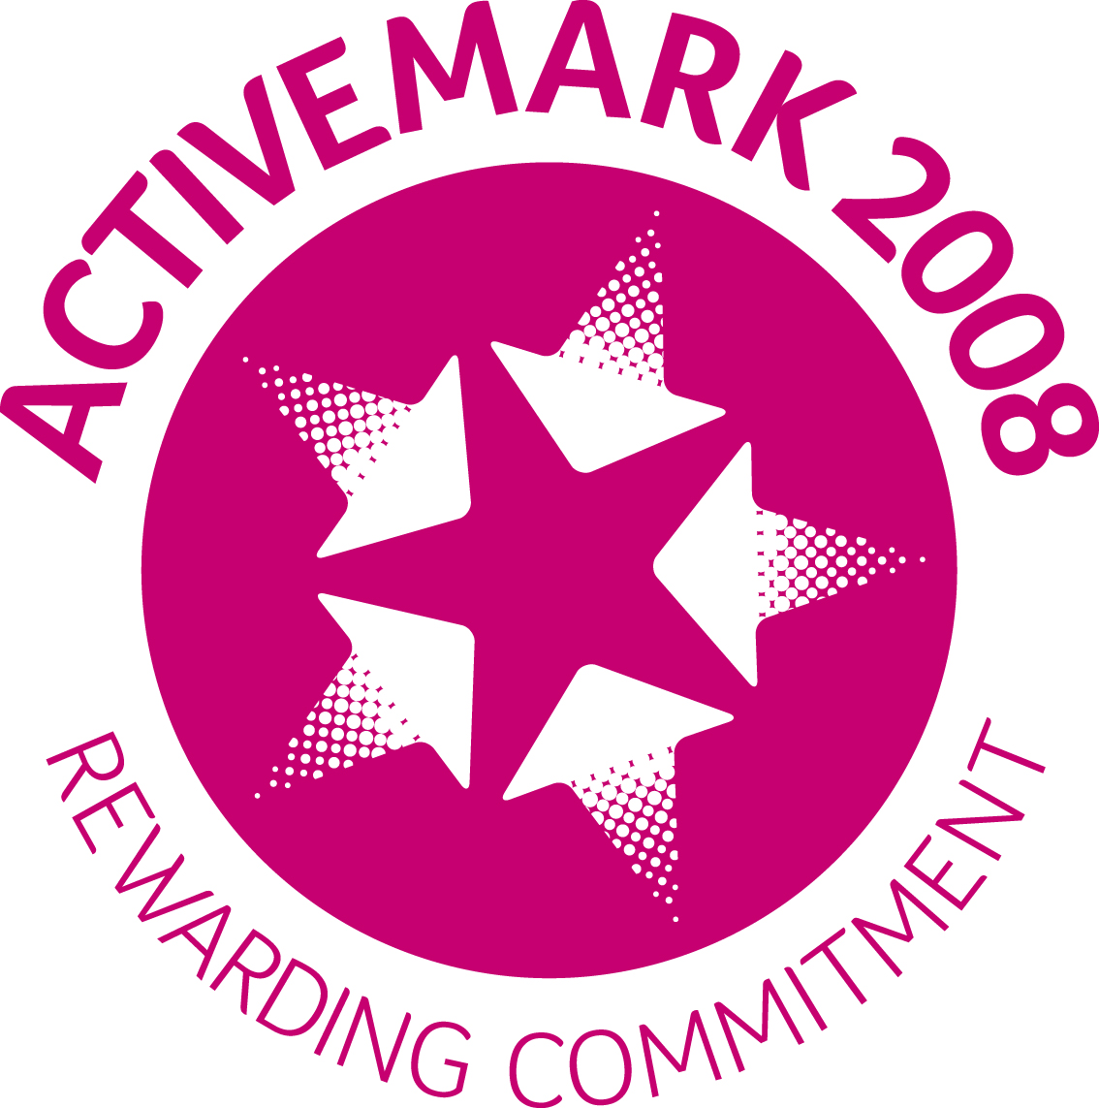




Headteacher

