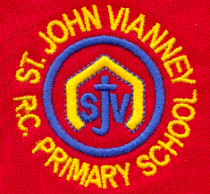

Dear Parents and Carers,
As part of our work on the Romans in our History curriculum this year, the children will be watching episodes from the BBC Childen’s Television series, ‘Roman Mysteries’ in school. The programmes will be watched under the supervision of myself and Mrs O’Neill and it will provide an opportunity for the children to learn about what life was like for children in the Roman Empire. It will be a lovely way to enrich the children’s learning in Year 3.
Roman Mysteries is a children’s television series created by the BBC in 2006; it is based on the historical novels of children’s author, Caroline Lawrence. It is the most expensive children’s television programme yet made, costing approximately a million pounds per hour to produce.
Thank you for your continued support, it is very much appreciated.
With every good wish,
Mr Galley

