


Hillhead Road
West Denton
Newcastle upon Tyne
NE5 1DN
Telephone: 0191 2672233
Fax: 0191 2679538
admin@stjohnvianney.newcastle.sch.uk
www.stjohnvianney.newcastle.sch.uk

Mr A M Duffy
Headteacher
St. John Vianney Catholic Primary School
©

14th February, 2020
Dear Parents and Carers,
Dates for Diary
After the half-term holidays, there is another busy week in school. I have included the list of events again for your information.
Tuesday 25th February: Mr Galley’s Y3 Class Visit to Pizza Express
Wednesday 26th February: Y6 out at the Theatre Royal to see “Holes”
Tuesday 3rd Match: Miss Dean’s Y3 Class Visit to Pizza Express
Thursday 5th March: World Book Day

World Book Day
To celebrate our love of Reading here at St. John Vianney school, we are celebrating a World Book Day week in school and we have a range of exciting activities planned. We will be having our traditional ‘Bring a Book and Swap a Book’ activity, where we invite children to bring into school a book that they have finished reading at home to swap for a different book with someone in their class. We are also aiming to have a sponsored Readathon in school in addition to our ‘Bookie with a Cookie’, which was very popular last year. We will be hosting Djembe Drummers in Early Years and Key Stage 1 to support the work we are doing on our African-themed Reading week as well as many other exciting Reading-based activities. We invite all of our children to come to school dressed as their favourite Book character and I know that this will be a brilliant day in school!

Parents Evening
We will be hosting our Spring term Parents Evening after the holidays, during week beginning 16th March. We will send out a letter after the holidays for you to indicate your preferences so please keep a look out for this.

Clubs
The letters for after-school clubs have been sent home tonight. All reply slips must be returned to school by Wednesday 26th February. Thank you.

PTFA
The next PTFA meeting will take place on Wednesday 26th February at 4.30pm. You are all most welcome to attend and we look forward to seeing you then.
Thank you for your continued support.
Yours sincerely,
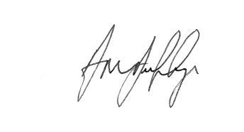
Mr A M Duffy









Headteacher

