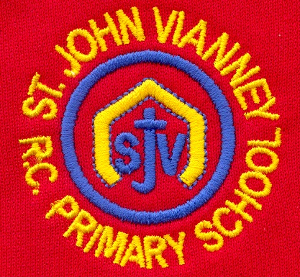

**PSHE**

**Health and wellbeing, relationships & Living in the Wider World.** Identifying the needs of people, knowing choices have consequences & people’s decisions and circumstances.

**Music**

Children will study Musicianship and they will explore pulse, rhythm, pitch and dynamics. They will play rhythms on percussion instruments and the xylophone.

**P.E. *Games:*** Ball skills, dribbling, kicking and hitting. Team games and rules. Link to different games and sports. **Gymnastics** – floor skills and balance.

**Mathematics**

**Arithmetic tests / Times Tables Rock Stars**

***Measurement:*** Use rulers, scales, thermometers and measuring vessels to recognise m / cm, l / ml and g / kg. Accurately read temperature in Celsius, estimate temperature and read thermometers to confirm the estimate

***Statistics:*** read, interpret, analyse and construct picture graphs

***Place value:*** Use place value and number facts to solve problems. Estimate and identify missing numbers using a number line.

***Developing and Applying calculation:*** Recall addition and subtraction facts to 20 fluently. Add and subtract numbers. Use a blank number line to record calculations.

***Multiplication and Division*:** Recall and use multiplication and division facts for 2, 3 5, and 10 times tables. Count in steps of 2, 3, 5 and 10 from any number forwards and backwards. Recognise odd and even numbers.

**Art**

**Sculpture and 3D: Clay Houses** Develop understanding of sculpture to construct and model simple forms; Develop simple skills for shaping and joining clay; Follow a plan for a making process, modifying and correcting things.

**History**

***The Great Fire of London*** Explore different sources to find out about the past. Describe, compare and discuss chronologically.

**French**

Children will sequence a story in French (*Toutes les Couleurs*). They will name colours and body parts in French.

**Computing**

Digital trails, algorithms, introduction to coding, programming and debugging.

**Geography**

***Weather:*** *Different types of weather; The Four Seasons; Weather in the UK; Investigating Weather*

**Year Two – Spring Term**

**Science**

***Materials:***

*Identify and group everyday materials; Record observations; Explore different properties of materials; Changing the shape of materials; Explore the difference between solids, liquids and gases*

**English**

***On the Way Home: Fiction***

Characters; retell; discussion & comprehension. Different

***Dictionary Skills:*** Alphabetical order, word meanings and glossary use.

***Poetry: In the Land of the Giants by George Szirtes*** Poetry comprehension; Vocabulary; Poems about a familiar topic; Acrostic Poems

***Report: The Great Fire of London***

***The Proudest Blue by Abtihaj Muhammad*** *Stories from other cultures*

***SPAG (Spelling Punctuation & Grammar):*** Capital letters and full stops, exclamation marks, speech marks, commas in a sentence, conjunctions & past and present tense. Phase 5 phonics. Guided / individual reading.

**Religious Education**

***Books***

Bible stories from the New and Old Testament. Exploring The Bible. **Why do we need books?**

***Thanksgiving (Eucharist)***

The Last Supper. Learn about parts of The Mass / responses used by the parish family.

**Why should we be grateful people?**

***Opportunities***

Lent / Easter. The importance of Holy Week.

**How does each day offer opportunities for good?**

***Other Faiths: Islam***

Prayer at home.