
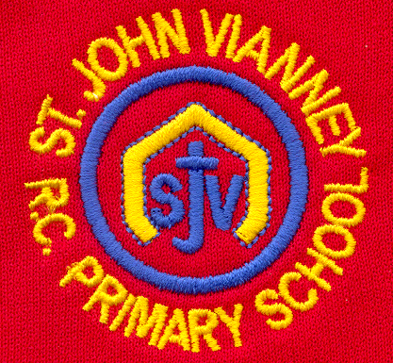

Hillhead Road
West Denton
Newcastle upon Tyne
NE5 1DN
Telephone: 0191 2672233
Fax: 0191 2679538
admin@stjohnvianney.newcastle.sch.uk
www.stjohnvianney.newcastle.sch.uk

Mr A M Duffy
Headteacher
St. John Vianney Catholic Primary School
©

13th September, 2019

Dear Parents and Carers,

Year 4 First Holy Communions
I will be sending out a letter on Monday outlining the preparation course for all of our Year 4 children who will be making their First Holy Communion in May.
Father Martin would like to meet with all parents and carers of Year 4 children who will be making their First Holy Communion on Thursday 3rd October at 6.00pm in St. John Vianney church hall. This meeting will last approximately 45 minutes.
Please note that it is assumed that every child who is a baptised Catholic in St. John Vianney school will make their First Holy Communion. If there is a reason why your child, who is a baptised Catholic, will not be making their First Holy Communion, then you must make an appointment to come and see me to discuss this matter further. Thank you for your support in this matter.

Year 6 visit to Safety Works
Year 6 had a super visit to Safety Works yesterday. They found out more about Fire Safety, staying safe on the Metro and they took part in a workshop organised by St. John Ambulance Brigade. It was an excellent trip and the children all tell me that they learned a lot about staying safe. Well done to all of our Year 6 children whose behaviour, I am told, was impeccable as always. Well done Year 6.

PTFA Autumn Fayre
On Friday 27th September, our PTFA are hosting an Autumn Fayre at 3.00pm in St. John Vianney Parish Hall and they need your help!

They are in desperate need of donations of bottles, chocolates and tombola prizes and any bric-a-brac you may have at home for the stalls. Please send all donations into school by Tuesday 24th September. If anyone is able to donate any prizes for our big raffle then that would be greatly appreciated. We already have some wonderful prizes courtesy of Newburn Leisure Centre and local cafes/restaurants, but any other prizes would be most welcome.
They also desperately need volunteers to help so, if anyone could spare an hour to help on a stall, could you please let a member of the PTFA or Mrs Meldrum/Mrs McDine know. Thank you in advance for your generosity.
There will be more information to follow so please keep a look out for this.

School Uniform
It is lovely to see all of our children wearing the correct school uniform at the start of this new academic year. Can I please ask you to make sure that you have your child’s name clearly labelled in their uniform as we already have a pile of lost property comprising brand new jumpers and cardigans.

Diary
Can I please remind you that Monday 23rd September is a Teacher Training Day and school will therefore be closed to all pupils.
Can I also remind you that May Day (Early May Bank Holiday) has moved to 8th May 2020 (Friday) as part of the 75th anniversary of VE Day commemorations. Please bear this is mind when consulting our school holiday list from Newcastle City Council.

ALDI’S KIT FOR SCHOOLS
We are collecting Team GB stickers with Aldi’s Kit for Schools. Help us to collect 300 stickers to complete our poster and school will receive an exclusive sports kit and a chance to win £20,000! Thank you in advance for your support.

We have had another lovely week back and we look forward to working with you all over the forthcoming months because, working together, we really can achieve the very best for the children of St. John Vianney Catholic Primary school.

Yours sincerely,

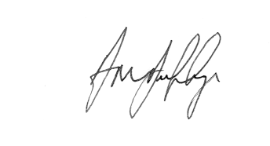
Mr A M Duffy
Headteacher











