
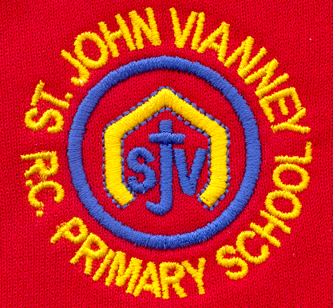

Hillhead Road
West Denton
Newcastle upon Tyne
NE5 1DN
Telephone: 0191 2672233
Fax: 0191 2679538
admin@stjohnvianney.newcastle.sch.uk
www.stjohnvianney.newcastle.sch.uk

Mr A M Duffy
Headteacher
St. John Vianney Catholic Primary School
©

22nd March, 2019
Dear Parents and Carers,

Parent’s Evening
Thank you to all of our parents and carers who came into school this week to meet with their child’s class teacher. It really was a very well attended Parent’s Evening. I must say a big thank you to all of our teachers, who stayed behind for three very long nights to accommodate all of their parents and carers. I have received very positive feedback from you about the flexibility of appointments so thank you to you all.

Year 1 Liturgy
Mrs McLean’s Year 1 class would like to invite their parents/carers and friends to their Class Liturgy next Wednesday, 27th March, at 9.15am in the school hall. We look forward to seeing you there.

Reception Trip to the Farm
On Wednesday 27th March, Mr Cowen and Mrs Duffy’s Reception classes will be visiting Hall Hill Farm. A separate letter containing additional information has already been sent out but spare copies are available from the school office. The weather forecast is good so our Reception children should have a fabulous trip finding out more about their topic, Down at the Farm.

After-School Handover
It has been brought to my attention from both parents and staff that some of our children are running around parked cars in the staff car park once they have been dismissed by their class teacher. Cars enter and exit the car park at all times during the day and the safety of all of our children, whilst they are on school property, is my upmost priority. Can I therefore please insist on your co-operation in ensuring that children are supervised once they have been handed over by their class teacher to support us in our safeguarding policy. Thank you.

After-School Clubs
Our after-school clubs begin again next week and they will run until the end of this half-term. I will be writing to you soon with details of next half-term’s clubs once I have received confirmation from all of our after-school providers.

Rescheduled First Holy Communion Session
The rescheduled First Holy Communion session will take place next Thursday, 28th March, in the school hall.

Congratulations Mrs O’Neill!
I am delighted to inform you that Mrs O’Neill had a beautiful baby girl, Isabella Rose, last Thursday and they are both doing extremely well. I am sure you will join me in wishing Mrs O’Neill and her husband all the very best at this exciting time.

Thank you for your continued support of our school.

Yours sincerely,
Mrs C Meldrum
Acting Headteacher











