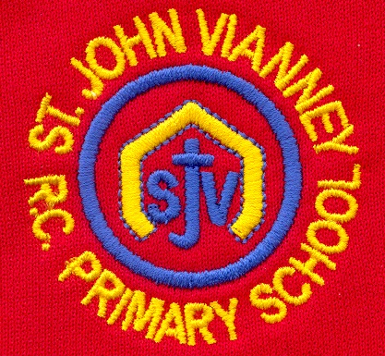

**French**

To say how you come to school; infinitive form of the verb; begin to conjugate regular present tense -er verbs; ask and answer questions; revise numbers 1-40; school subjects.

**Mathematics**

***Percentages:*** Finding the percentage of a number; finding the percentage of a quantity; finding percentage change, using percentages to compare.

***Measurement***: Converting units (metric and imperial units); finding the area and perimeter of shapes (rectangles, parallelogram and triangles).

***Ratio and Proportion:*** to use ratios and fractions to compare objects; to find the relationship between ratios, percentages and fractions; to compare numbers using ratios; to make decisions about simplifying ratios using division.

***Geometry and Statistics:*** Position & direction; properties of shapes; angles.

***Position and Direction:*** coordinates on all four quadrants; translation and reflection; compass points.

***Algebra:*** formulae; linear number sequences; missing numbers; pairs of numbers to satisfy equations; finding all possible solutions.

***Statistics:*** pie charts; drawing and interpreting graphs; miles to km; mean as an average; Venn and Carroll diagrams.

**History**

***World War Two (continued):*** key events, key figures; causes; propaganda; children in the war; the Blitz; evacuation; effects; analysing sources.

**P.E.**

***Gymnastics:*** gymnastic sequences; using apparatus; travel; speed; positioning

**Music**

Children will begin to play the guitar and keyboard and they will read rhythms and musical notes. They will perform and improvise pieces of music individually and as an ensemble.

**PSHE**

Health and Wellbeing; Relationships; Living in the Wider World

**Religious Education**

**Local Church: Sources**

The Bible and its books and authors

**Eucharist: Relating – Unity**

The Eucharist challenges and enables the Christian family to live and grow in communion every day

**Lent: Easter**

The Church’s seasons of Lent, Holy Week and Easter; the suffering, death and resurrection of Jesus led to newlife

**Other Faiths: Islam**

Guidance for Muslims: The 5 Pillars and Zakat

**Science**

***Light:*** Light sources; shadows; how light travels;using mirrors; different materials and light; practical investigations.

***Electricity:*** what is electricity;electrical circuits; electrical resistance; testing circuits; practical investigations.

**English**

***‘The Diary of Anne Frank’:*** Biography and autobiography

***‘Letters From The Lighthouse’ by Emma Carroll:*** Diary entry; Letter; Newspaper article; Persuasive speech; narrative

***‘Oliver Twist’ by Charles Dickens:*** Character description; Formal police report; classic narrative

***Persuasive Writing:*** Holiday brochures; campaigns linked to current climate issues

***Grammar:*** revision of Autumn Term grammar; parenthesis; subjunctive form; prefixes/suffixes; hyphens; apostrophes; conjunctions; semi-colons; tenses.

**Computing**

***Programming:*** introducing variables; variables in programming; improving a game; designing a game; design to code; improving and sharing***.***

**Art and Design Technology**

To explore, develop and refine a range of drawing skills (line, shape, shade, hatching.

**Year Six – Spring Term**