
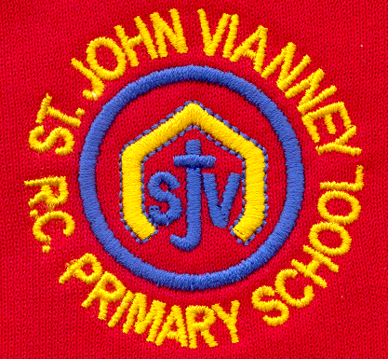

Hillhead Road
West Denton
Newcastle upon Tyne
NE5 1DN
Telephone: 0191 2672233
Fax: 0191 2679538
admin@stjohnvianney.newcastle.sch.uk
www.stjohnvianney.newcastle.sch.uk

Mrs C Meldrum
Acting Headteacher
St. John Vianney Catholic Primary School
©

6th November, 2020

Dear Families,

Welcome Back!
I would like to welcome you all back to school after the half-term holidays. The children have settled back into school really well again and it is wonderful to hear that they are working hard and trying their best in school as always. Thank you for your continued support with all of our systems and procedures in school.
In the current situation, I would like to thank the vast majority of our parents and carers for wearing a face mask when they enter the school grounds at pick-up time and I would like to thank those of you who are exempt from wearing a face covering for informing school of this. I would be very grateful if you could inform anyone new collecting your child that they are required to wear a face covering on school grounds – thank you for your co-operation in this.

Harvest Festival Day – 13th November
This year, we are celebrating Children In Need Day and Harvest Festival on Friday 13th November. Children are invited to come into school wearing their own clothes and/or Pudsey clothes and accessories. We will not be collecting any monies on the day in light of the current situation, but we are inviting children to bring a can/tin/packet of food into school on Friday 13th November and these will be collected in plastic containers at the entrance to school. The West End Food Bank will collect all donations of food on Friday afternoon. In this way, we are able to support children within our local area on Children In Need Day. Thank you in advance for your donations.

School Uniform Policy
A big thank you to you all for following our School Uniform Policy especially with regard to earrings following my request earlier in the term. Can I please remind you that hair accessories should be plain and they can be red, blue or black in colour. Thank you.

Anti-Bullying Week
On Monday 16th November, we will be celebrating Anti-Bullying Week in school. The theme this year is United Against Bullying. Mrs Langford, our PSHE Co-ordinator, has organised a timetable of activities for all of our children and we are inviting all of our children to come in to school wearing odd socks on Monday 16th November to celebrate differences and diversity. We look forward to an exciting week!

First Holy Communion for Year 5 children
Congratulations to our Year 5 children who made their First Holy Communion during the half-term holidays. It was a very special day for them all.
As you will be aware, the national lockdown has resulted in the closure in places of worship and this has halted our First Holy Communions because St. John Vianney church will remain closed until 2nd December. Miss Elliott and Father Martin will write to Year 4 parents and carers next week once we have been able to rearrange dates for the children who will miss their First Holy Communion due to Lockdown in line with Diocesan guidance. We pray for all of our Year 5 children during this very challenging time.

COVID-19 Contact
If you need to contact school over the weekend regarding COVID-19 issues, please contact me at admin@stjohnvianney.newcastle.sch.uk.

With my very best wishes,
C.Meldrum
Acting Headteacher

