Physical development  Gross motor skills – Develop core strength and agility by running, hopping, jumping, skipping, climbing safely.  Building with crates and planks  Carrying, dragging, balancing  Transporting big equipment safely  Using bats and balls  Games skills with the PE coach  Fine motor skills – develop careful controlled movements and the pincer grip for writing by threading, posting and manipulating beads, glass jewels and pebbles.  Screwing with nuts and bolts, sew, use finger puppets, manipulate dough and clay  Writing letters and numbers with the correct formation, facing the correct way.  Cut straight and curved lines  Building with construction material  Using a stapler, split pins and sellotape dispenser | Personal, Social and emotional Education  Learning classroom routines, washing hands, routines for coughing and sneezing, tidy up time, signal for stop and listen, sharing resources, taking turns, winning and losing games.  Through stories talk about;  - Caring for plants and animals  - Keeping safe  - Being a good friend  - Persevering  - Sharing fairly  - Helping others  - Working together | Mathematics  Number  Subitising when looking at arrangements of objects.  Counting aloud  Counting objects  Sorting and matching  Remembering number facts by heart  Explaining their thoughts and understanding about maths.  Use mathematics apparatus to develop understanding of;  Building numbers beyond 10  Counting patterns beyond 10  Addition  Subtraction  Doubling  halving  Sharing and grouping  Odd and even  Shape, Space and measure  Spatial reasoning – shape challenges  Identify patterns and relationships  Weight and capacity | Literacy  Phonics –hearing, recognising and writing sounds. Segment words for writing.  Learn to read tricky words by sight  Reading  Blend letters to read words, plans, maps, recipes, instructions, books  Writing  Label maps plans and pictures.  Write instructions, lists, cards and make mini books  Core books  On the way home – Jill Murphy  Mr Gumpy’s Outing – John Burningham  All aboard for the Bobo Road – Christopher Corr  The Little Red Train to the Rescue – Benedict Blaythwayt  Astro Girl – Max Wilon  Mad about Minibeasts – Giles Andreae  Superworm – Julia Donaldson  Snail Trail – Ruth Brown  The Very Greedy Bee – Steve Smallman  The Bad-tempered Ladybird – Eric Carle
Communication and language
Use new vocabulary introduced as part of their topic.
Speak in coherent sentences.
Answer how and why questions.
Explain their ideas.
Retell their narrative of an event.
Re-enact a story.
Join in with refrains, poems and rhymes
Storytelling sessions in a group
Reception Class  Summer Term 1 Journeys  Summer Term 2 Out and About  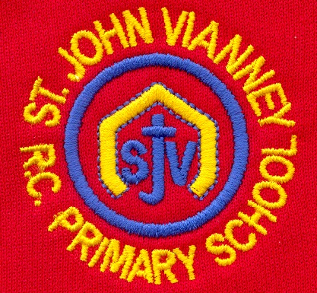 | Religious Education  Daily prayers  Making the sign of the cross  Taking part in a liturgy  Serving – Everyone has good News to share. At Pentecost we share the good news of Jesus  Friends – Jesus had good friends. He tells us about friendship  Our World – God gave us a wonderful world | Expressive art and design  Making a 3-d map of the area  Drawing a map of their journey to school  Printing  Building a boat which floats  Making a rocket  Making clay minibeasts  Natural material collage  Poly prints  Andy Goldsworthy inspired nature transient art  Snail art inspired by Matisse | Knowledge of the world  Investigating floating and sinking  Looking at and drawing maps  Comparing different landscapes – Burkina Faso and West Denton  Caring for chicks  Investigate floating and sinking  Finding out about life in Space  Looking at using the interactive white board, lightbox and cd player independently.  Close observation of worms and snails  Mini-beast hunt sorting and classifying minibeasts  Building a mini-beast hotel.  Recycling

