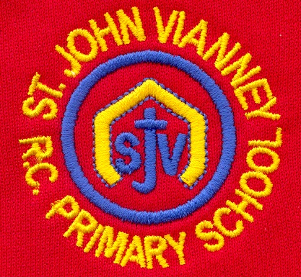

**Music**

The children will write music using crotchets, quavers, minims, semi-quavers and more complex time signatures to make their own compositions. They will then perform this as part of an ensemble.

**P.E.**

**Athletics:** sprinting; running; takeoff and landing; hurdles; throwing

**French**

***Un Pays Francophone:*** plan an itinerary for a journey to St Lucia; research St Lucia and write about it in French

**Design Technology**

**Electrics:** approach a design brief; using skills and knowledge, design a product that is fit for a purpose; develop practical skills that they will apply to creating their products; assess the quality of their work and improve, if necessary, throughout the design and construction process.

**Art**

***Printing***

Investigate and evaluate Pop Art; design a piece of printed Pop Art; evaluate own art work.

**Religious Education**

**Pentecost – Serving: Witnesses**

Know and understand:

• The courage to be a witness – Explore

• Pentecost: The Holy Spirit enables people to witness to the Easter message

**Reconciliation: Inter-relating**

Know and understand:

• When people become sick and need care – Explore

• The Sacrament of the Anointing of the Sick

**Universal Church: Common Good**

Know and understand:

• Justice for the good of all

• The work which Christians do for the common good of all

**Mathematics**

***Number and Place Value:*** Multiplying and dividing by powers of 10; place value of each digits in numbers up to 10 million; reason about numbers; round numbers; divide into 2, 4, 5 and 10 equal parts

***Four Operations:*** Understand that 2 numbers can be related additively or multiplicatively; derive related calculations, using inverse relationships; solve Problems with 2 unknowns

***Fractions/Decimals/Percentages:*** Recognize when fractions can be simplified; use common factors to simplify; express fractions in a common denomination; compare fractions that are similar in value; solve problems involving the calculation of percentages

***Geometry:*** Draw, compose and decompose shapes including dimensions, angles and area; solve shape problems

**Ratio:** Solve problems involving the relative sizes of two quantities

***Money****:* Money sense resources from Natwest and Barclays

**Science**

***Evolution and Inheritance:*** Recognise that living things have changed over time and that fossils provide information about living things that inhabited the Earth millions of years ago; recognise that living things produce offspring of the same kind, but normally offspring vary and are not identical to their parents; identify how animals and plants are adapted to suit their environment in different ways and that adaptation may lead to evolution.

**PSHE**

Health and Wellbeing

Living in the World

Relationships

**History**

***The Mayan Civilisation:*** develop knowledge and understanding of a non-European ancient culture; describe how Mayan society functioned from second hand sources; make links and contrasts with modern European life.

**English**

***Persuasive Writing:*** Holiday brochures; campaigns linked to current climate issues

***Film:*** Writing inspired by short film clips, including police reports, letters, diary entries and narrative including flashbacks

***The Raven by Edgar Allen Poe:*** study of narrative poem The Raven; writing a synopsis, review, a poem and a piece of narrative

***Cosmic Disco:*** poetry for performance; a poem about school experiences for performance.

***Grammar:*** revision of all KS2 grammar

**Computing**

e-Safety

Programming

Multimedia

The role of technology in our lives

**Geography**

***Map Skills***

Consolidation of Geography learning through Key Stage Two.

***Field Work***

Orienteering; data collection

**Year Six – Summer Term**